AIM
Activity Journals Creation Inbound
MD.120 deployment Instructions

Author: Mohi Uddin
Creation Date: Sep 21,2025
Last Updated:
Version: 1.0

- Download the FBDI Template for Journals creation.
- After downloading the xlsm template unlock the file from properties.
- Remove the sample data that sheet contains and then copy the headers and paste below it to use in oic mapping.
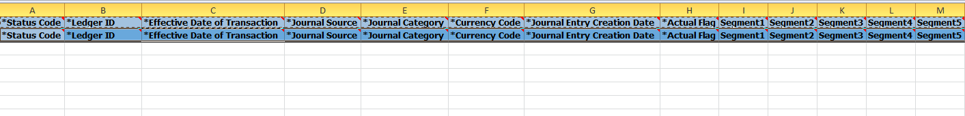
- Now click on Generate CSV file,so that the csv file and a zip file will be created.
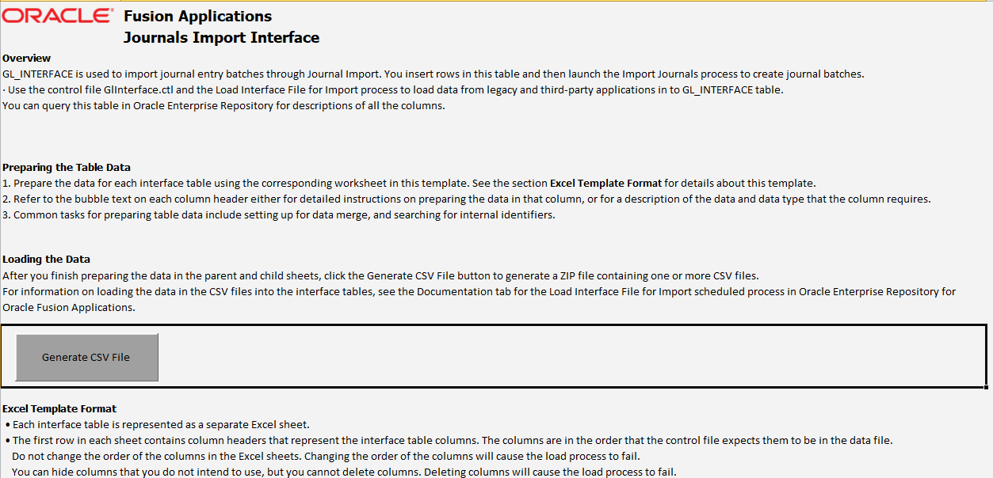

- Now create a source file which contains suplliers information to be upload in ERP Cloud.
- Place that source file into the FTP server.

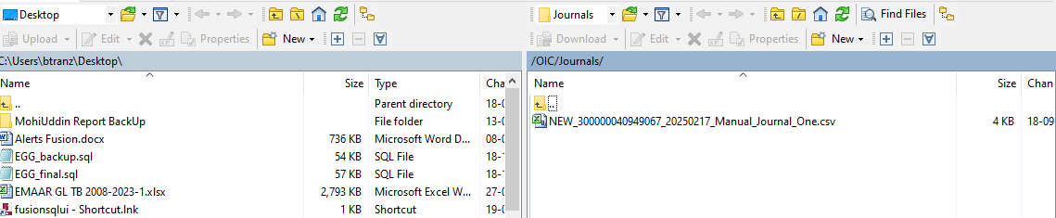

- Now in OIC create 3 connections : REST,FTP and Oracle Cloud ERP.
- Now create an Application Integration by giving the name of the integration.

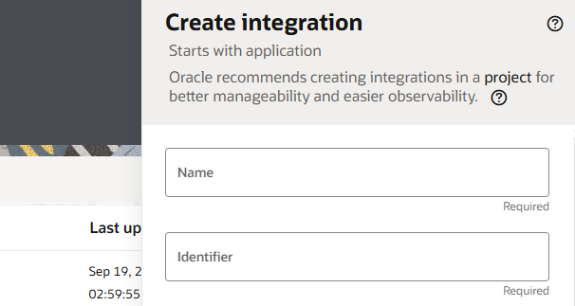

- Create one end point by using the Rest Connection.
- Give the end point name and click on continue.
- Now in next step give the URI,end point action and then click on continue.
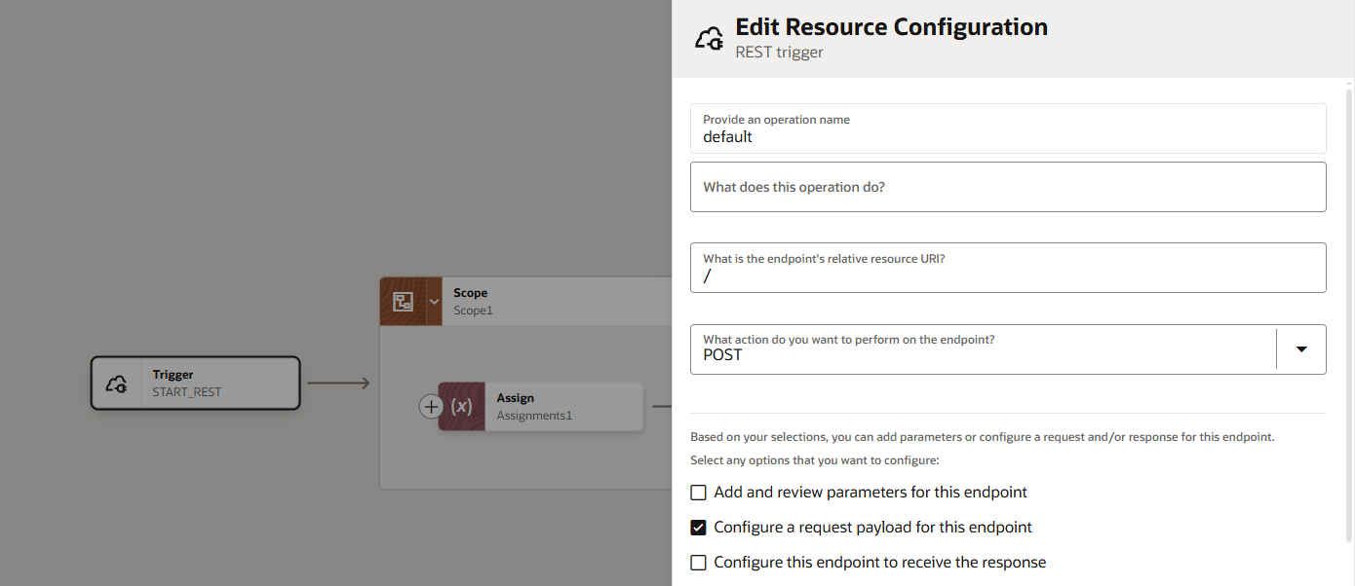

- After that click on Finish.
- The Integration end point will be appeared at canvas

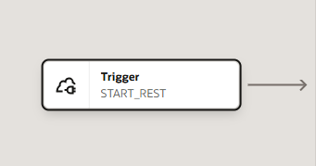

- Now take the FTP Connection to Read the file from the server and give the endpoint name

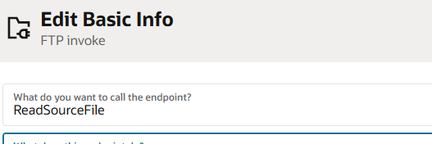

- Now select operation to read the file with dummy directory and file name

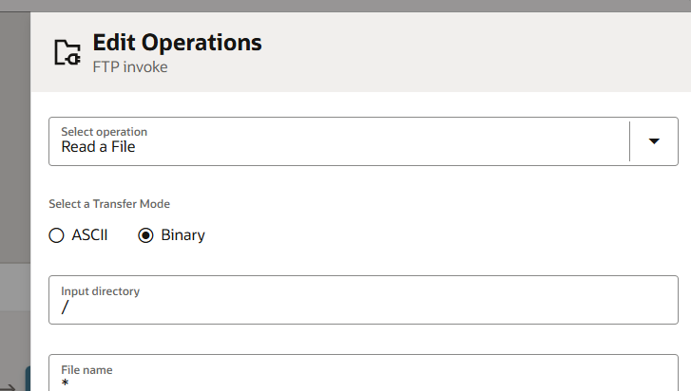

- Now edit the mapper of the FTP and give the Directory as FTP file Path.

- Now take one Stage File action to read from source file to stage file and give action name
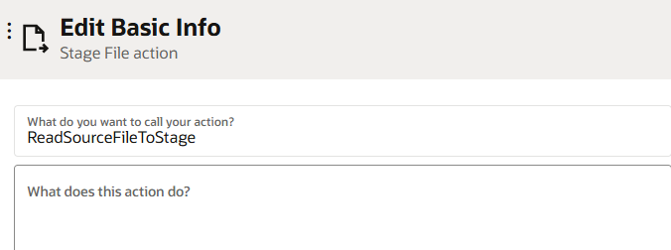

- In the next step give the give the file reference and select the operation.

- Now again take one stage File to write the data from the source file to the target file and give the action name as

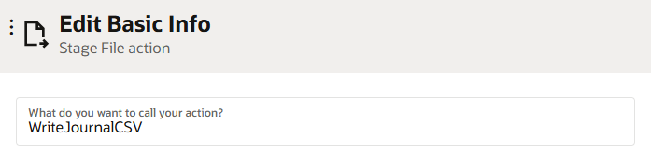

- Give the filename,directory and click on continue.

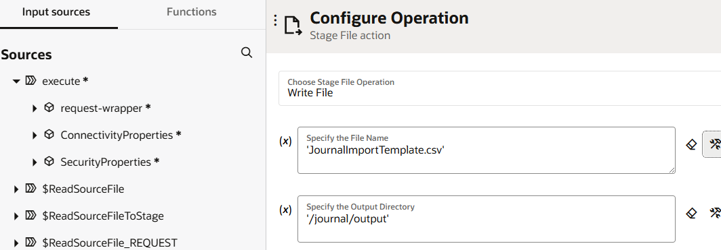

- Now provide the file format of the XLSM file and click on continue.

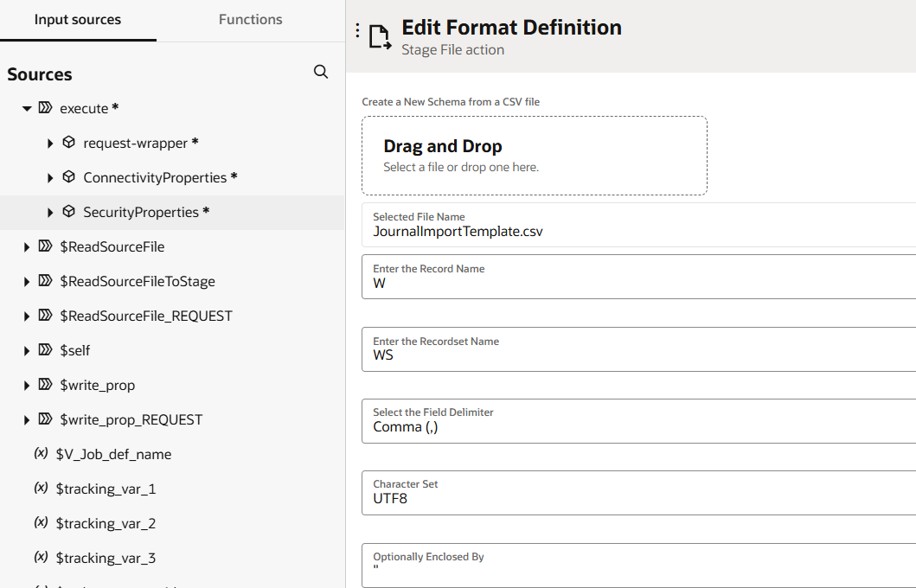

- Now edit the write file mapper and map the following
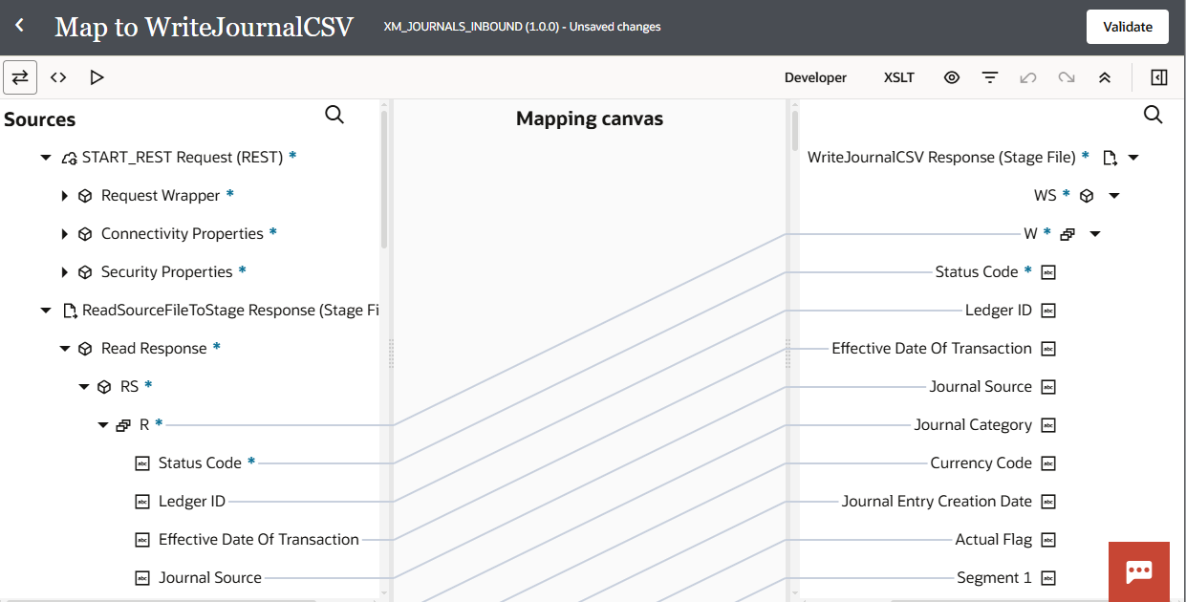

- Now create the properties file to invoke the ESS job.
- The details of the ESS job will be found at Application and the ESS job name is Impoer Suppliers

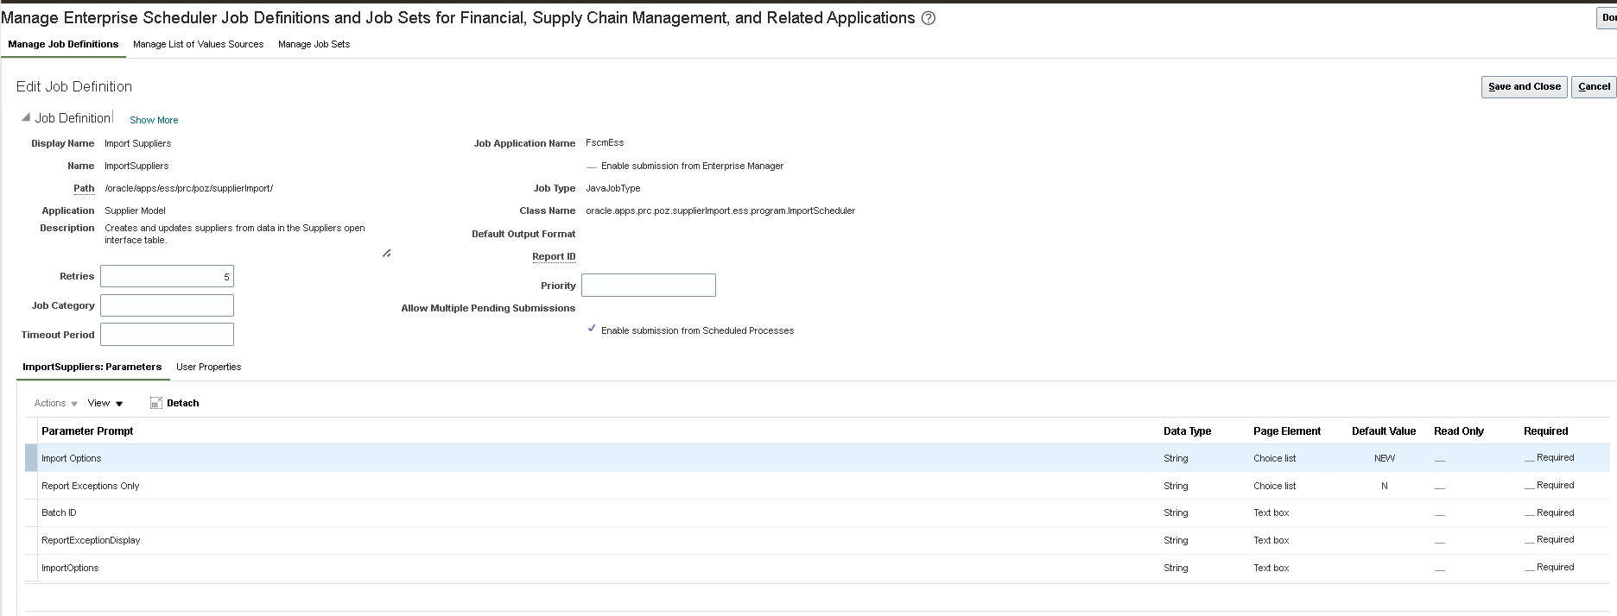

- Now create assign action and in that create variables to store the ESS job details.
- The value is ESS job Report path.
- For job definition the value is ESS job Name

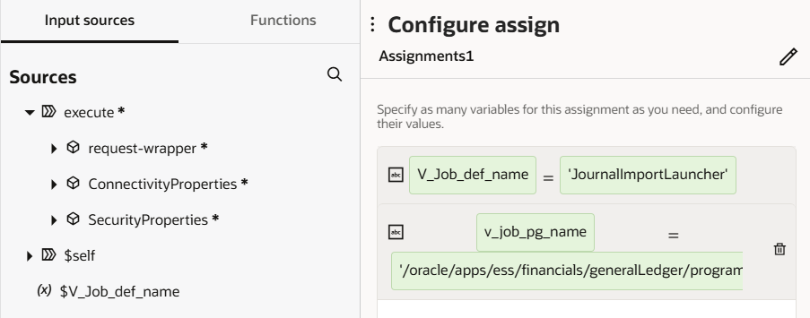

- Now edit the properties file mapper and map the following, give values to the arguments according to sheet data

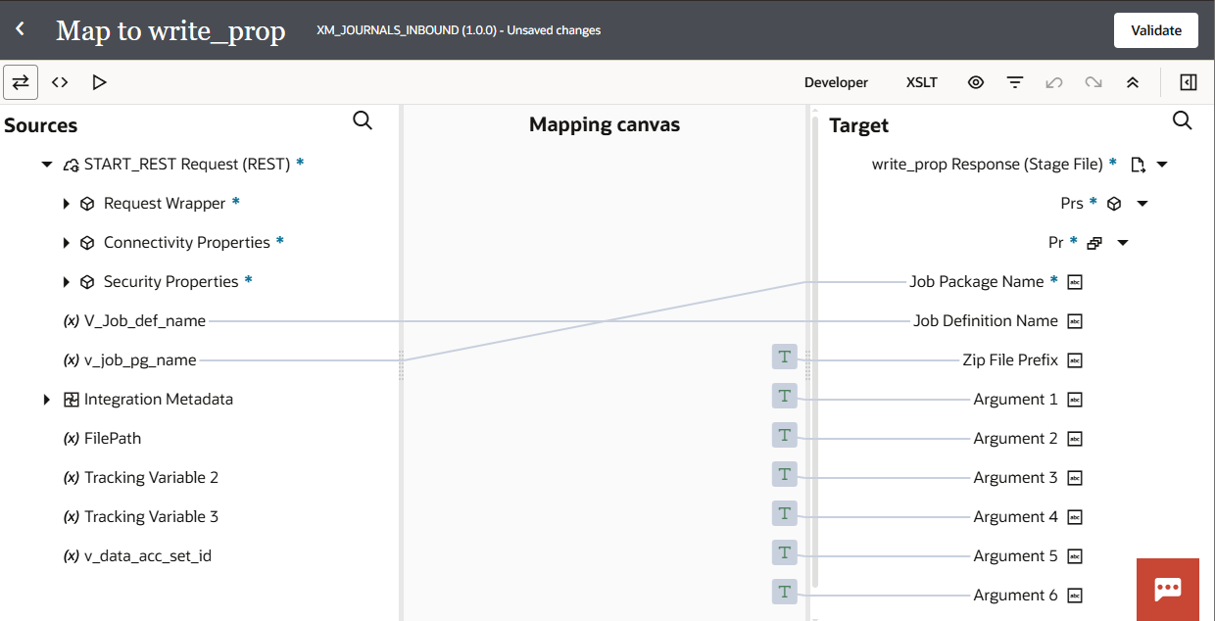

- Now create one zip file with the help of the stage file and give the action name as

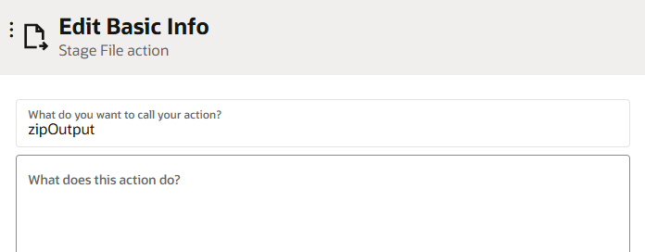
- Select the file operations and click on continue.

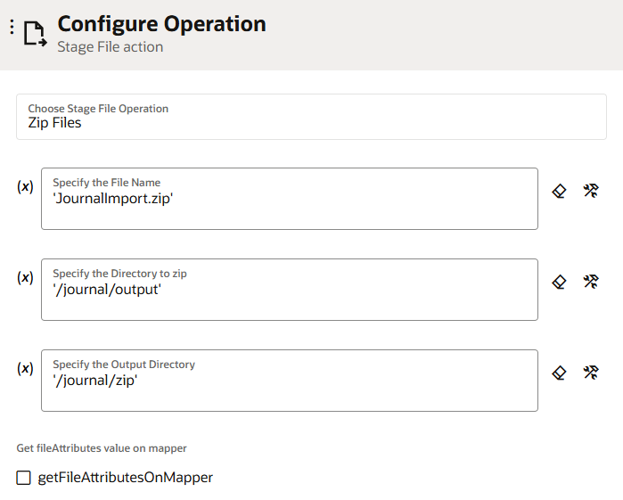

- Now add the ERP Cloud adapter and give the name as

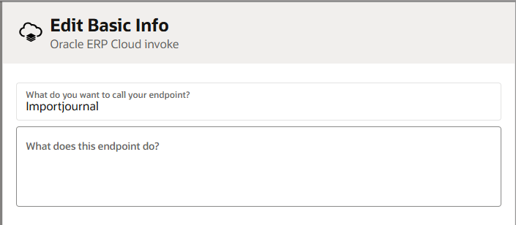

- Select the Import bulk data into oracle erp cloud and click on continue.

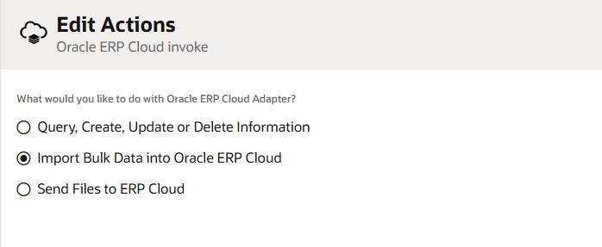

- Now select the method to import the data and click on continue.

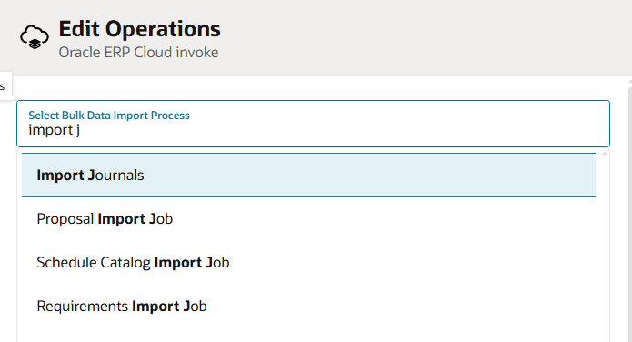

- Now edit the mapper of the Orecle erp cloud and map the following.

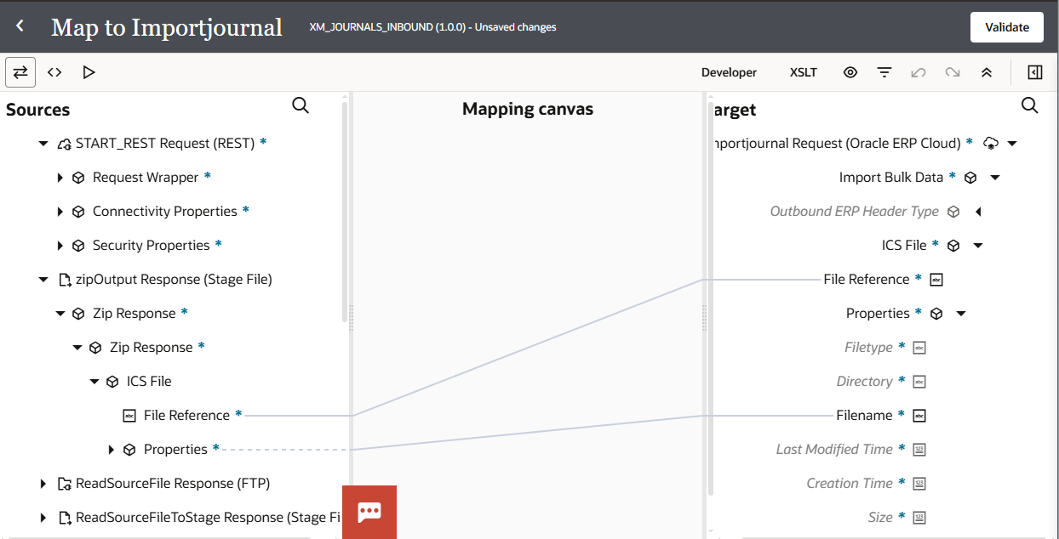

- Now add the business identifier and save the integration.
- Activate the Integration and run the integration.
- After Running the Integration you will receive a Process id in integration tracking level activity and we can search this process id status from ERP instance.

